Table of Contents
Executive Summary 3
1 Critical Analysis of Potential Risk Assessment Frameworks 4
Introduction 4
IEC 62443 4
NIST SP 800-82 5
ISO/SAE 21434 6
Conclusion 6
2Risk Analysis Using IEC 62443 8
2.1 Risk Assessment Methodology 8
2.2 Initial Risk Assessment (ZCR 2–4) 9
10
2.3 Detailed Risk Assessment 12
3 Recommendations 16
Bibliography 19
Appendix 1 22
Appendix 2 23

Executive Summary
This report presents the results of a cybersecurity audit of a major UK vehicle manufacturer, examining ten technologies deployed across its manufacturing plant and integrated vehicle systems. The organisation has operated for over twelve years without a formal security audit, and no documented patch management history was identified for the assessed assets.
Three cybersecurity frameworks were evaluated, the IEC 62443, NIST SP 800-82, and ISO/SAE 21434. IEC 62443 was selected as the primary framework due to its focus on industrial control systems, zone-and-conduit risk methodology, and alignment with emerging regulatory requirements such as the UK Cyber Security and Resilience Bill. The absence of structured patching, the presence of default credentials, and limited network segmentation indicate a current security posture consistent with IEC 62443 Maturity Level 1.
Assets were grouped into six operational zones and assessed using the IEC 62443-3-2 zonal cyber risk methodology. All zones produced impact scores between 4 (Major) and 5 (Critical), exceeding the tolerable risk threshold and triggering detailed assessment. Ten risks were identified.
The most critical vulnerability affects the DCT Syrus4 IoT gateway CVE-2023-6248, CVSS 10.0, enabling potential remote code execution on fleet telematics infrastructure. Default or hard-coded credentials were also identified across multiple assets.
Seven remediation actions are recommended, prioritised from Critical to Medium, establishing a maturity pathway from ML1 toward ML3. Immediate priorities include credential remediation, network segmentation, and isolation of the Syrus4 gateway. The organisation must also address regulatory obligations under the UK Cyber Security and Resilience Bill and UNECE Regulation 155, which requires a vehicle cybersecurity management system aligned with ISO/SAE 21434.

1 Critical Analysis of Potential Risk Assessment Frameworks

Introduction
Three cybersecurity frameworks were identified as potential candidates for this assessment. Each framework was critically evaluated against the organization’s operational and technological context to determine its suitability. The framework that best aligns with the system architecture, risk environment, and assessment objectives is selected to underpin the risk assessment.

IEC 62443
The IEC 62443 is a standard used for securing Industrial Automation and Control Systems (International Society of Automation, 2026). It was developed by the International Society of Automation and then adopted by the International Electrotechnical Commission.
It is made up of four series covering organisational security programmes (2-1), zone and conduit risk assessment (3-2), system-level security requirements (3-3), and component-level requirements alongside secure development lifecycle processes (4-2 and 4-1), enabling asset owners to manage cybersecurity both operationally and strategically. Risk is structured through Security Levels (SL1–SL4), which are used to depict attacker capability and impact, and Maturity Levels (ML1–ML4), which assess the consistency and sustainability of implemented controls over time (Da Silva , et al., 2025).

For this case, IEC 62443 shows the broadest device coverage. The ABB, KUKA and FANUC robot controllers map directly to its IACS control system requirements highlighted in IEC 62443-4-2. Whereas the COGNEX, AXIS, FLIR and Syrus4 devices are addressed as embedded and network industrial components. Eight of the ten assets listed fall within the scope of this framework. However, the AUTOCAD software is only partially addressable through the secure development lifecycle requirements highlighted in 62443-4-1 (International Electrotechnical Commission, 2018). The MIB Infotainment system lies outside the scope of this framework entirely.
Its risk methodology is comprehensive and prescriptive, as it uses a zone and conduit model. This enables the segmentation of interconnected factory systems, while Foundational Requirements define control families that cover authentication, integrity, data flow restriction and availability. This approach is well-suited to an organisation of low security maturity undergoing its first audit, as it provides clear, actionable directions as opposed to open-ended principles characteristic of governance-based frameworks, reducing the risk of inconsistent or insufficient control implementation where no established security baseline exists. IEC 62443 aligns closely with the cybersecurity risk management expectations of the UK Cyber Security and Resilience Bill and the UK NCSC guidance for industrial control systems (National Cyber Security Centre, 2026).

NIST SP 800-82
This framework was developed by the National Institute of Standards and Technology (NIST) and is designed to address the security of operational technology environments, including Industrial Control Systems, SCADA and network manufacturing infrastructure (National Institute of Standards and Technology, 2023). NIST SP 800-82 provides detailed technical guidance for securing industrial control systems and aligns with the broader NIST Cybersecurity Framework (CSF) risk management approach.
In terms of device coverage, the SP 800-82 maps closely to the plant assets used in this scenario. The ABB, KUKA and FANUC robot controllers, COGNEX inspection systems, AXIS and FLIR cameras, and the DCT Syrus4 IoT gateway can all be addressed within its OT security guidance. However, vehicle-integrated components such as the MIB3 infotainment unit fall outside its scope and it provides no automotive-specific provisions.
As NIST SP 800-82 is a subset of the larger NIST CSF 2.0, its risk methodology aligns closely with its parent framework. Where risk assessment is structured around system categorization, control selection, implementation, assessment, authorization, and continuous monitoring. Threats are categorized by impact to confidentiality, integrity, and availability; they are further grouped by threat source, adversarial, accidental, structural or environmental. Risk treatment is then mapped to the relevant NIST SP 800-53 control families, where threats are organized around impact domain and mitigation categories, as opposed to attacker capability tiers or segmented industrial zones (National Institute of Standards and Technology, 2023).
However, SP 800-82 is a guide and not a certifiable standard, it cannot be formally adopted or audited against the same way IEC 62443. It carries no regulatory weight under the NIS2 or UK NCSC mandates for industrial environments, limiting its standing as the primary compliance framework. SP 800-82 is therefore strongest as a supplementary technical reference (Abdolee, 2023).

ISO/SAE 21434
ISO/SAE 21434 is joint ISO-SAE standard for road vehicle cybersecurity engineering. It governs the full vehicle lifecycle from concept to decommissioning and introduces Threat Analysis and Risk Assessment (TARA) as its core methodology. It is designed for automotive OEMs and suppliers developing vehicle systems (Jayaratne, et al., 2026).
Its applicability is strong for the Volkswagen MIB3 infotainment unit and the Syrus4 telematics gateway, both of which align directly with connected vehicle architectures. Development tools such as AutoCAD may fall within lifecycle considerations. However, plant-level assets, including ABB, KUKA, FANUC controllers, COGNEX cameras, and industrial charging systems fall outside the scope of this framework. Only two to three of the ten assets are comprehensively addressed within this framework.
The TARA methodology provides rigorous attack path modelling and traceable cybersecurity goals for vehicle systems, offering depth within automotive embedded environments. However, it does not translate to industrial control system architecture or manufacturing automation risks (BYHON, n.d.).
ISO/SAE 21434 does not address IT/OT convergence in plant environments and contains no provisions for industrial segmentation or robotics security. It is mandated under UNECE R155 for vehicle type approval in the UK and EU, giving it strong regulatory relevance (CYBERLIFEHACKS, 2026). Nevertheless, its product-centric scope and high implementation complexity make it unsuitable as a primary framework for a first-time factory-wide audit.

Conclusion
Each framework evaluated presents distinct strengths and limitations within this audit context. NIST SP 800-82 offers technically relevant OT guidance but lacks certifiability and regulatory standing, rendering it unsuitable as a primary framework. ISO/SAE 21434 provides rigorous vehicle cybersecurity engineering through its TARA methodology, and whilst directly applicable to the MIB3 and Syrus4, its product-centric scope excludes most plant-based assets and carries high implementation complexity for a first-time audit.
IEC 62443 emerges as the most defensible primary framework across all evaluated criteria. Its coverage of eight of the ten assets, prescriptive zone and conduit methodology, and dual SL/ML model provide both the technical depth and structured progression required for an organisation of low security maturity undergoing its first audit. Its recognition under the NIS2 Directive further strengthens its regulatory legitimacy in this context. Whilst its limitations regarding the MIB3 and AutoCAD are acknowledged; no single framework comprehensively addresses the dual plant and vehicle scope of this inventory. IEC 62443 therefore provides the most complete and operationally relevant foundation for the risk analysis conducted in this report.

2Risk Analysis Using IEC 62443

2.1 Risk Assessment Methodology
The assessment follows the IEC 62443-3-2 Zonal Cyber Risk (ZCR) methodology. The System Under Consideration (SUC) consists of the manufacturing Industrial Automation and Control System (IACS) environment in which the identified technologies operate.
The ZCR process begins by defining impact criteria representing cyber-physical consequences relevant to manufacturing environments, including safety, operational continuity, and regulatory exposure. Assets are then grouped into logical zones and conduits based on operational function.
An initial consequence-driven assessment is conducted assuming a credible compromise scenario where likelihood = 1 to identify zones where successful compromises would exceed tolerable organizational risk. These zones are then subjected to detailed risk analysis to determine Security Level Targets (SL-T), threat scenarios, and mitigation controls.

Table 1 IEC 62443 Security Levels and Protection Objectives
Security Level | Protection Objective
SL0 | No specific cybersecurity requirements.
SL1 | Protection against casual or accidental violation.
SL2 | Protection against intentional violation using simple means and limited resources.
SL3 | Protection against intentional violation using sophisticated means and moderate resources.
SL4 | Protection against highly sophisticated, well-resourced adversaries (e.g., nation-state).

2.2 Initial Risk Assessment (ZCR 2–4)
Using the methodology described above, an initial screening assessment was conducted to identify zones where compromise would produce unacceptable operational or safety consequences. Impact criteria were defined to reflect cyber-physical manufacturing risks, prioritising safety, operational continuity and regulatory exposure.
Assets were grouped into operational zones and evaluated using worst-case consequence modelling. This preliminary assessment establishes the potential impact of compromise within each zone and enables the assignment of provisional Security Level Targets (SL-T) in accordance with IEC 62443 (Patrick O'Brien, exida, 2020).
Zones demonstrating impact above the organisation’s tolerable risk threshold were then selected for detailed threat analysis, presented in the subsequent risk register.
Impact Criteria
Score | Descriptor | Definition
1 | Negligible | No production loss or injury.
2 | Minor | Local disruption, no line stoppage.
3 | Moderate | Single-line disruption or reportable breach.
4 | Major | Multi-line halt or serious injury risk.
5 | Critical | Full site shutdown, fatality risk, major regulatory action.

Initial Consequence Screening by Zone
Production Control | ABB IRC5, Industrial Robot Ctrl v8.23, KUKA KR C4/C5, COGNEX 3D-A1000 | Robot or inspection manipulation causing production stoppage and safety risk | 5 | SL3
Engineering Workstation | AutoCAD 2025 (Translators) | Malicious CAD files enabling design tampering or OT pivot | 4 | SL2–3
Surveillance / Security | AXIS Q6128-E PTZ, FLIR AX8 | Loss or compromise of surveillance visibility | 4 | SL2
Energy Infrastructure | Siemens VersiCharge | Charger manipulation disrupting facility operations | 4 | SL2
Vehicle Systems | VW MIB Infotainment | Infotainment compromise exposing data or vehicle systems | 4 | SL2
Fleet Operations | DCT Syrus4 IoT Gateway | Telematics compromise enabling fleet-wide disruption | 5 | SL3
All identified zones produced impact scores between 4 and 5, illustrated using the table above. This indicates the consequences exceed the organisation’s tolerable risk threshold. Therefore, all zones were selected for detailed risk analysis, where specific vulnerabilities, threat scenarios and mitigation strategies are analysed.

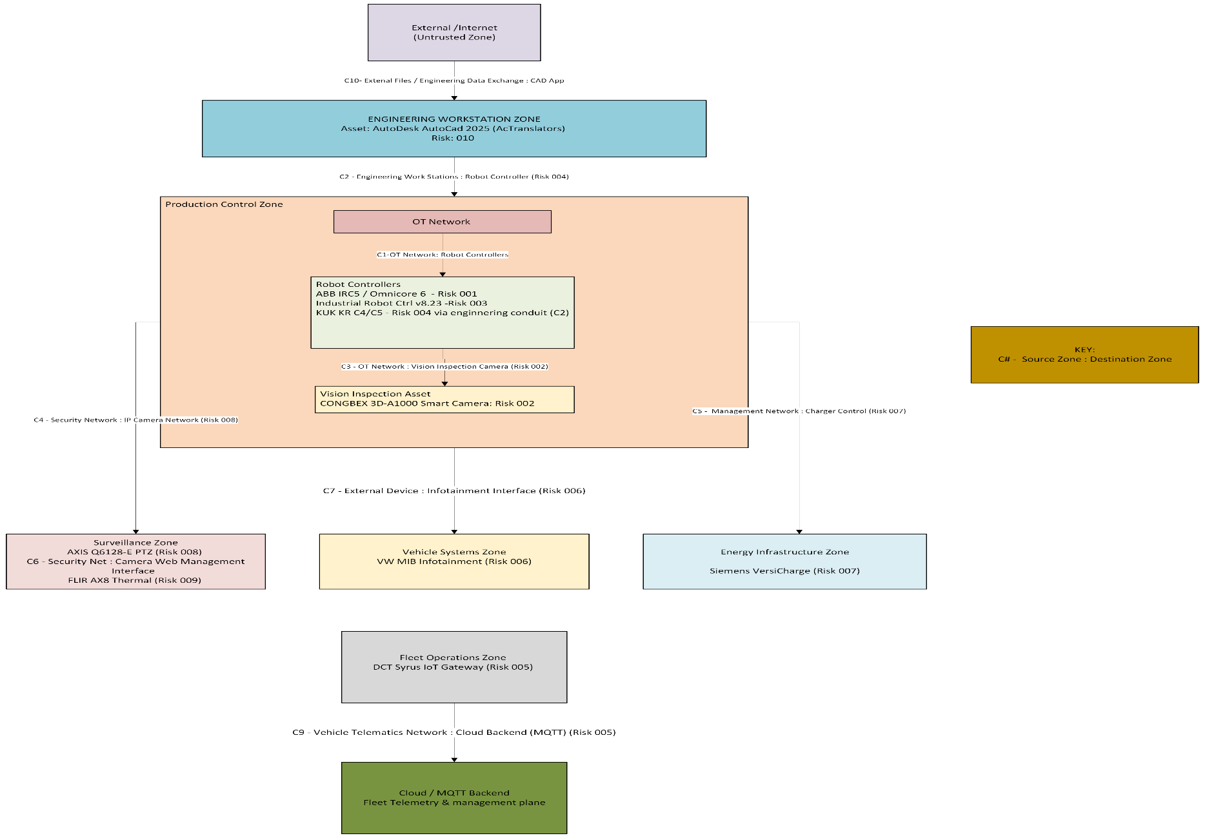
Figure 1 illustrates the resulting zone and conduit architecture, showing logical trust boundaries and communication pathways used during the detailed threat analysis.

2.3 Detailed Risk Assessment

Following the initial zonal consequence assessment, a detailed risk register was developed to systematically evaluate vulnerabilities affecting assets within the SUC. The risk register provides a structured record of identified cyber risks, including the affected zone and conduit, asset, threat scenario, vulnerability, potential consequences, and corresponding mitigation measures.
Risk ratings were derived using a standard 5 by 5 impact–likelihood matrix, where the overall risk score is calculated as the product of impact and likelihood. Impact reflects the potential operational, safety, regulatory and financial consequences of a successful attack, while likelihood reflects the probability of exploitation based on vulnerability severity scoring (CVSS), accessibility of the attack surface, and attacker capability.
Security Level Targets (SL-T) were assigned to indicate the level of protection required against increasing attacker sophistication. The mitigation measures listed correspond to security controls intended to reduce either the likelihood or impact of each threat scenario, thereby reducing residual risk to an acceptable level within the defined zones and conduits.

Risk ID | Zone | Conduit | Asset | Threat Scenario | Vulnerability | Consequences | CVSS | Impact | Likelihood | Risk | SL-T | Risk Owner | Mitigations
001 | Production | OT: Robot Controller | ABB IRC5 / Omnicore 6 | Remote exploitation of RobotWare services | CVE-2024-1913 / 1914 | Production downtime, defective builds, safety investigation (HSE/RIDDOR), financial & reputational impact | 7.6 / 6.5 | 4 | 3 | 12 | SL-2 | Head OT Infrastructure | Patch firmware, segment OT network, restrict engineering access, disable unused services, enforce authentication, IDS/IPS monitoring
002 | Production | OT :Vision Camera | COGNEX 3D-A1000 Smart Camera | Unauthorized camera configuration access | CVE-2022-1522 / 1368 / 1525 | Manipulated inspection data, defective products, logistics disruption, compliance breach, financial & reputational impact | 5.3 / 9.8 / 9.1 | 5 | 4 | 20 | SL-2 | Head OT Infrastructure | Apply vendor patches, restrict camera access, enforce RBAC authentication, disable unused services, centralized logging, vulnerability scanning
003 | Production | OT : Robot Admin Interface | Industrial Robot Controller (v8.23) | Web admin service exploitation | CVE-2019-13584 / 13585 | Robot task manipulation, production stoppage, safety investigation, financial & reputational impact | 5.3 / 9.8 | 5 | 3 | 15 | SL-2 | Head OT Infrastructure | Patch firmware, restrict admin web access, segment OT network, disable remote admin, monitor TCP 8090 traffic
004 | Production | Engineering WS : Robot Controller | KUKA KR C4 / C5 Controller | Engineering service authentication bypass | CVE-2021-33016 / 33014 / 2242 | Robot program manipulation, system compromise, production disruption, safety investigation, financial impact | 9.8 / 8.8 / 9.8 | 5 | 4 | 20 | SL-3 | Head OT Infrastructure | Upgrade KSS/VSS ≥8.6.5, migrate to KSS 8.7, change credentials, restrict WorkVisual access, OT segmentation, enable USB security & application whitelisting

005 | Fleet Operations | Vehicle Telematics : Cloud (MQTT) | DCT Syrus4 IoT Gateway | MQTT backend exploitation | CVE-2023-6248 | Remote fleet control, vehicle tracking, service disruption, safety risk, financial & regulatory impact | 10.0 | 5 | 5 | 25 | SL-3 | Head Fleet Systems / OT Infrastructure | Isolate gateways, restrict MQTT via firewall/VPN, disable remote control features, monitor MQTT traffic, segment fleet networks
006 | Vehicle Systems | External Device : Infotainment | VW MIB Infotainment | Bluetooth exploitation | CVE-2023-28905 / 28909 / 28910 / 28906 | Infotainment compromise, data access, potential network pivoting, driver distraction, financial & reputational impact | 8.0 / 8.0 / 8.0 / 7.8 | 4 | 3 | 12 | SL-2 | Head Vehicle Systems Security | Restrict Bluetooth pairing, remove old pairings, disable contact sync, restrict OBD/USB access, apply firmware updates
007 | Energy Infrastructure | Management Network : Charger | Siemens VersiCharge Charger | Modbus service exploitation | CVE-2025-31929 / 31930 | Charging disruption, firmware manipulation, electrical safety concerns, operational downtime, monetary loss | 4.1 / 8.8 | 4 | 3 | 12 | SL-2 | Head Infrastructure / OT Systems | Update firmware ≥V2.135, disable Modbus via VersiCloud, restrict charger network access, isolate chargers, monitor device traffic
008 | Surveillance | Security Network : IP Camera | AXIS Q6128-E PTZ Camera | Malformed Ethernet frame attack | CVE-2024-47257 | Loss of surveillance coverage, delayed incident detection, security investigation, operational disruption | 7.5 | 3 | 4 | 12 | SL-2 | Head Physical Security / OT Infrastructure | Update firmware ≥6.50.5.19, segment camera VLANs, restrict internet exposure, VPN remote access, monitor abnormal traffic

009 | Surveillance | Security Network → Camera Interface | FLIR AX8 Thermal Camera | Web interface exploitation | CVE-2022-37061 / 4364 / 37062 / 37063 | Root command execution, data exposure, surveillance disruption, financial & reputational impact | 9.8 / 6.9 / 7.5 / 5.4 | 4 | 3 | 12 | SL-2 | Head Physical Security / OT Infrastructure | Upgrade firmware ≥1.49.16, restrict web interface access, CCTV VLAN segmentation, enforce authentication, monitor logs
010 | Engineering | External Files → CAD Application | AutoCAD 2025 (AcTranslators) | Malicious CAD file exploitation | CVE-2024-8592 / 8598 / 8591 | Engineering workstation compromise, design file loss, OT lateral movement, IP exposure, financial impact | 7.8 / 7.8 / 7.8 | 4 | 3 | 12 | SL-2 | Head Engineering IT / OT Infrastructure | Apply Autodesk patches, restrict untrusted CAD files, file sandbox scanning, application whitelisting, isolate engineering networks
The impact and likelihood values assigned within the register were supported by empirical evidence regarding the economic consequences of cyber-induced downtime in automotive manufacturing environments. Studies modelling cyber disruption to automobile production systems show that manufacturing facilities are highly dependent on networked industrial control, telecommunications, and digital ordering systems, meaning disruption to these systems can halt assembly operations and propagate across the supply chain. Economic modelling of a cyber-attack affecting the automotive sector estimates that a 10-day disruption could reduce production productivity by approximately 20% and result in regional GDP losses of around $41.7 million, with potential national economic losses exceeding $1.5 billion if disruption impacts the wider industry (Rose & Chen, 2017). These findings demonstrate that cyber incidents affecting operational technology environments can produce significant operational and financial consequences through business interruption and cascading supply-chain disruption. Consequently, assets capable of affecting manufacturing continuity were assigned high impact ratings (4–5) within the risk matrix, while likelihood ratings were determined by combining vulnerability severity scores, exposure of network services, and attacker capability assumptions consistent with IEC 62443 threat models.

Recommendations

The following recommendations address both identified technical vulnerabilities and the organisation's broader security posture. The assessment revealed systemic weaknesses including absent security governance, a flat network architecture, and no patch management history, conditions that significantly amplify individual device risks. The cost of inaction includes regulatory penalties under the UK Cyber Security and Resilience Act, potential RIDDOR obligations, and reputational damage. Recommendations are prioritised to maximise risk reduction per unit of organisational effort, whilst establishing controls to improve long-term security maturity aligned with IEC 62443 (Nicasie, 2024)

Table 2: Prioritised Risk Mitigation Recommendations Aligned with IEC 62443
Priority | Recommendation | IEC 62443 Reference | Evidence | Cost/Effort | Benefit
Critical | Immediate credential remediation across all assets with default or hard-coded credentials. Credential management has never been enforced, creating trivial unauthorized access across production and surveillance zones | SR 1.1, SR 1.2, IEC 62443-2-1 | CVE-2021-33016/33014 (KUKA, Risk 20 | Low ; policy change and device reconfiguration only | Eliminates the most prevalent vulnerability class immediately; no capital expenditure required
Critical | Enforce network segmentation and zone/conduit architecture across all operational zones. Flat network means a single compromise enables lateral movement across all zones | IEC 62443-3-2, SR 5.1, SR 5.2 | Risk IDs 004, 005 (SL-3, Risk Score 20–25); flat network amplifies cascading risk | Medium; network redesign and firewall reconfiguration | Contains blast radius of any compromise; foundational prerequisite for all subsequent controls
Critical | Isolate DCT Syrus4 IoT Gateway immediately. CVE-2023-6248 (CVSS 10.0) requires only a device IP to enable arbitrary code execution, vehicle immobilization, and data exfiltration. Vendor initially failed to respond to disclosure | SR 4.1, SR 5.1, IEC 62443-3-3 | CVE-2023-6248 (Risk 25, SL-3) | Low; firewall rule and network policy change | Highest risk-reduction-per-effort ratio in the register; eliminates CVSS 10.0 exposure immediately
High | Establish a formal patch management program prioritizing CVSS ≥8.0 vulnerabilities. Zero patching history across all ten assets represents an organizational governance failure | IEC 62443-2-3, SR 7.6 | CVE-2022-37061 (FLIR, 9.8), CVE-2021-33016 (KUKA, 9.8), CVE-2023-28905 (MIB3, 8.0) | Low-Medium; process establishment and maintenance windows | Addresses seven CVSS ≥7.5 CVEs across the register
High | Deploy OT monitoring and IDS/IPS across SL-3 zones. Neither Production nor Fleet Operations zones have confirmed detection capability, leaving dwell time unconstrained following compromise | SR 6.1, SR 6.2, IEC 62443-3-3 | Risk IDs 004, 005 (SL-3, Risk Score 20–25) | Medium-High; OT monitoring tooling such as Claroty or Dragos | Active detection in the two highest-risk zones; enables incident response capability
Medium | Establish cybersecurity governance with assigned risk ownership and documented security policies. No governance structure exists after 12+ years of operation | IEC 62443-2-1, UK Cyber Security and Resilience Bill | First audit in 12+ years; no baseline posture confirmed | Low; policy and documentation investment | Prerequisite for ML2 progression
Medium | Engage OEM vendors for MIB3 and Syrus4 regarding outstanding patches and UNECE R155 compliance obligations. Seven CVEs remain unpatched on the MIB3 alone | ISO/SAE 21434, UNECE R155, IEC 62443-4-2 CR 6.1 | CVE-2023-28905/28907/28906 (MIB3, Risk 12), CVE-2023-6248 (Syrus4, Risk 25) | Low; vendor communication and procurement | Reduces vehicle regulatory exposure; supports UNECE R155 type approval obligations

The recommendations follow a maturity progression consistent with IEC 62443's ML model (Exida, 2018). The three critical actions credential remediation, segmentation, and Syrus4 isolation, are foundational controls required to transition from ML1, where processes are absent, to ML2, where controls are planned and consistently executed (Sadoian, 2025). Importantly, all three require configuration and policy changes rather than significant capital investment, maximising risk reduction per unit of effort for an organisation with no established security budget. Governance and monitoring represent the longer-term trajectory towards ML3, where practices are institutionalised across the organisation.
The register findings should not be interpreted in isolation. The convergence of a flat network, zero patching history, and hard-coded credentials creates compounding exposure that individual risk scores understate. A successful exploitation of CVE-2023-6248 on the Syrus4 could provide an entry point for lateral movement across all zones under current conditions, making the organisation's true risk posture materially worse than the aggregate register suggests (Sadoian, 2025).
Finally, the manufacturer faces a dual regulatory obligation. The UK Cyber Security and Resilience Act governs the operational environment, whilst UNECE R155 applies to vehicle type approval (Vehicle Certification Agency, 2025).The unpatched vulnerabilities on the MIB3 and Syrus4 indicate that vehicle compliance obligations under UNECE R155, supported by a dedicated ISO/SAE 21434 programme, require separate and urgent organisational attention (United Nations Economic Commission For Europe, n.d.).

Bibliography
Abdolee, R., 2023. Best Standard for Your ICS Security, IEC-62443 or NIST-SP-800-82. [Online]
Available at: https://novesh.com/blog/novesh-blog-7/best-standard-for-your-ics-security-iec-62443-or-nist-sp-800-82-12#:~:text=Certifications:%20The%20ISA/IEC%2062443,NIST%20SP%20800%2D82%20standard.
[Accessed 5 March 2026].
Applus Laboratories, n.d. IEC 62443-4-1 and IEC 62443-4-2 standards for Industrial Cybersecurity. [Online]
Available at: https://www.appluslaboratories.com/global/en/what-we-do/service-sheet/iec-62443-4-1-iec-62443-4-2-standards-industrial-cybersecurity#:~:text=Evaluation%20and%20certification%20under%20the,host%20components%20and%20software%20applications.
[Accessed 2026 March 2026].
BYHON, n.d. IEC 62443 vs. ISO 21434. [Online]
Available at: https://www.byhon.it/iec-62443-vs-iso-21434/#:~:text=ISO%2021434,-Reading%20time%3A%204&text=While%20IEC%2062443%20is%20the,21434%20addresses%20the%20automotive%20market.
[Accessed 5 March 2026].
CYBERLIFEHACKS, 2026. Regulations & Alignment. [Online]
Available at: https://www.cyberlifehacks.dev/iso21434/Regulations#:~:text=Regulations%20&%20Alignment,the%20requirements%20of%20UNECE%20R155.
[Accessed 5 March 2026].
Da Silva , M., Mocanu, S., Puys, M. & Thevenon, 2025. Safety-security convergence: Automation of IEC 62443-3-2. Computers & Security, Volume 156.
Exida, 2018. IEC 62443: Levels, Levels and More Levels. [Online]
Available at: https://www.exida.com/blog/iec-62443-levels-levels-and-more-levels
[Accessed 5 March 2026].
International Electrotechnical Commission, 2018. Security for Industrial Automation and Control Systems. [Online]
Available at: https://cdn.standards.iteh.ai/samples/21445/5d9b618cf732432b83b4e17e0e7b24cf/IEC-62443-4-1-2018.pdf
[Accessed 5 March 2026].
International Society of Automation, 2026. "The World’s Only Consensus-Based Automation and Control Systems Cybersecurity Standards." (“International Society of Automation (ISA)”) [Online]
Available at: https://www.isa.org/standards-and-publications/isa-standards/isa-iec-62443-series-of-standards
[Accessed 5 March 2026].
Jayaratne, D.N.D, LU & Rakib, 2026. A quantitative methodology for systemic impact assessment of cyber threats in connected vehicles. Computers & Security, Volume 160.
National Cyber Security Centre, 2026. Operational Technology. [Online]
Available at: https://www.ncsc.gov.uk/collection/operational-technology/secure-connectivity/principle-1
[Accessed 5 March 2026].
National Institute of Standards and Technology, 2023. NIST SP 800-82 Rev. 3. [Online]
Available at: https://csrc.nist.gov/pubs/sp/800/82/r3/final
[Accessed 5 March 2026].
Nicasie, V., 2024. IEC 62443: the essential standard for industrial cybersecurity. [Online]
Available at: https://www.stormshield.com/news/iec-62443-the-essential-standard-for-industrial-cybersecurity/#:~:text=However%2C%20the%20IEC%2062443%20standard,%2C%20and%20with%20international%20scope.%E2%80%9D
[Accessed 5 March 2026].
Patrick O'Brien, exida, 2020. Cybersecurity Risk Assessment According to ISA/IEC 62443-3-2. [Online]
Available at: https://www.automation.com/article/cybersecurity-risk-assessment-according-to-isa-iec-62443-3-2
[Accessed 5 March 2026].
Rose, A. & Chen, Z., 2017. Resilience to a Cyber-Attack on the Automobile Industry: A Computable General Equilibrium Approach, Los Angeles: University of Southern California – Sol Price School of Public Policy.
Sadoian, L., 2025. Industrial Control Systems Security: ISA 62443-2-1:2009. [Online]
Available at: https://www.upguard.com/blog/isa-62443-2-1-2009
[Accessed 5 March 2026].
United Nations Economic Commission For Europe, n.d. UN Regulation No. 155 - Cyber security and cyber security management system. [Online]
Available at: https://unece.org/transport/documents/2021/03/standards/un-regulation-no-155-cyber-security-and-cyber-security
[Accessed 5 March 2026].
Vehicle Certification Agency, 2025. Cyber Security and Software Updating. [Online]
Available at: https://www.vehicle-certification-agency.gov.uk/connected-and-automated-vehicles/cyber-security-and-software-updating/
[Accessed 5 March 2026].

Appendix 1
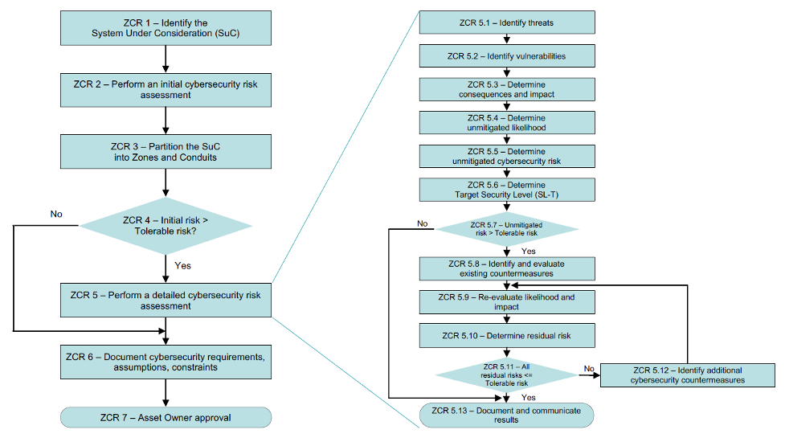
b IEC 62443-3-2 Zonal Cyber Risk (ZCR) assessment methodology illustrating the stages from system identification to residual risk determination and approval.

Appendix 2

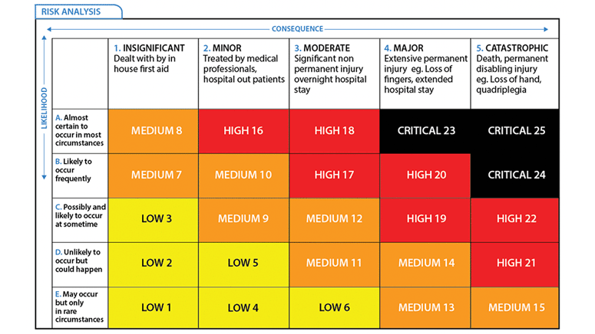
c Five-by-five risk matrix used in the detailed IEC 62443 risk assessment to determine overall risk scores by combining likelihood of exploitation with operational consequence severity.

